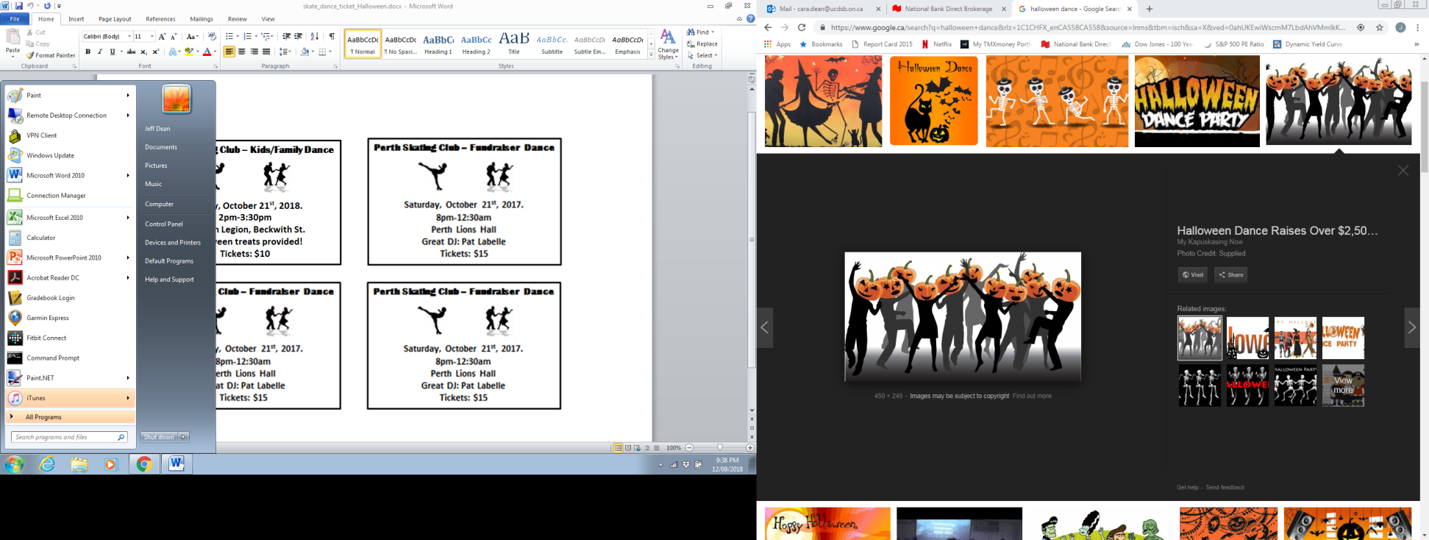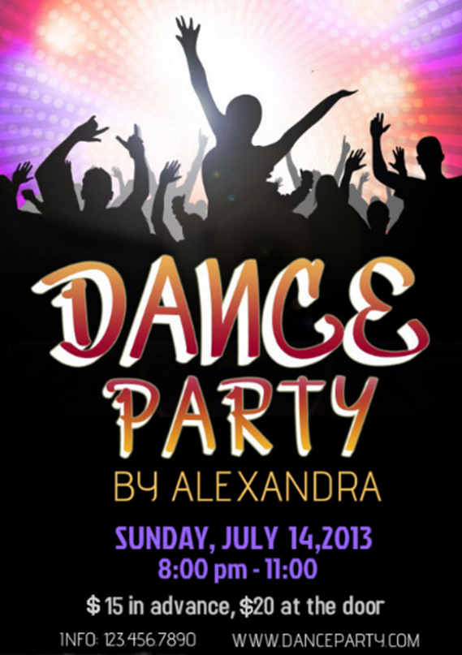

***Sunday, October 21st, 2018***

***2pm-3:30pm***

***Perth Legion***

***Tickets $5***

***Call Today: 613-267-9504***

***Kids/Family Halloween Dance***

***Proceeds support the Perth Skating Club***